**Advanced CSS Combining Selectors**

**Note:**

When there is space between selectors then hierarchy is from **right to left** and when there is **no** space between selectors then the hierarchy is from **left to right.**



Syntax:

Selector 1, selector 2,……. Selector n{  
 properties;

}

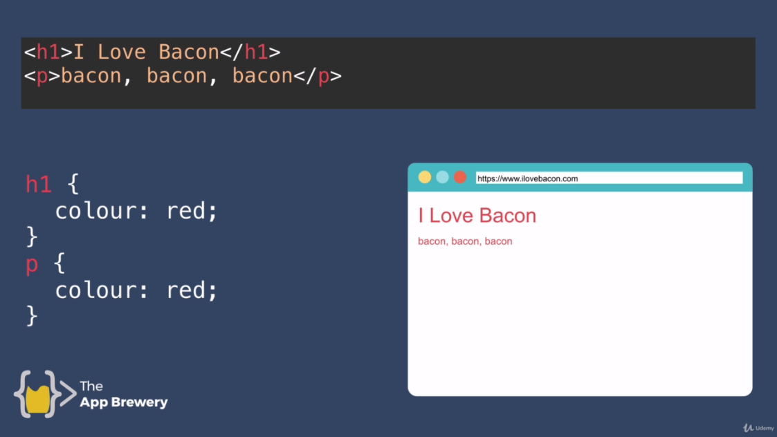

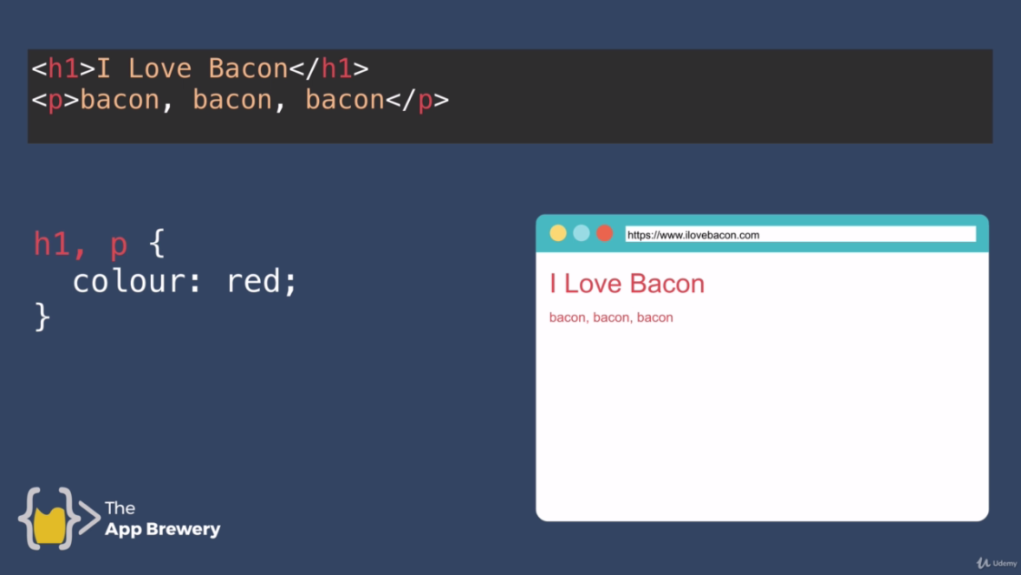

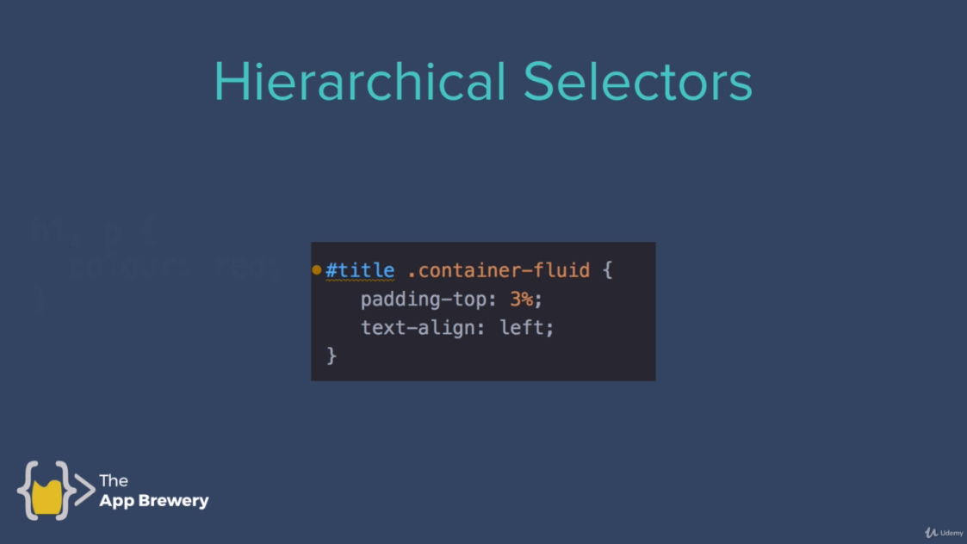

**Syntax:**

<id><space><class>{

}

Space in this case is necessary.



We will read from right to left. For example h1 text color of div will be red as given below.

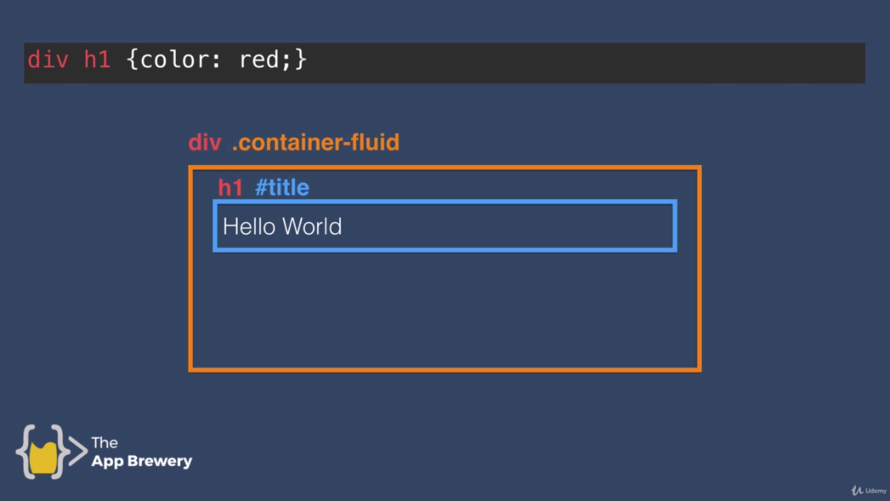

Title of container-fluid class will be red.

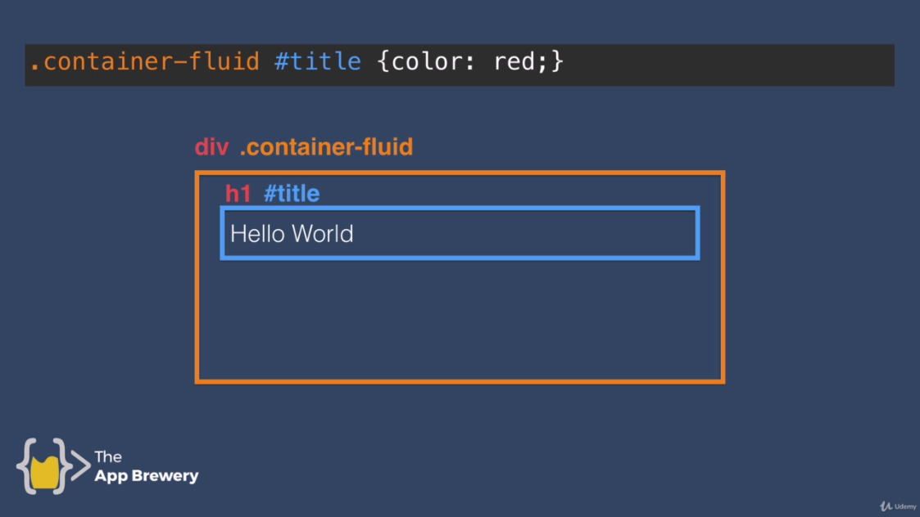

H1 text of container class will be red.

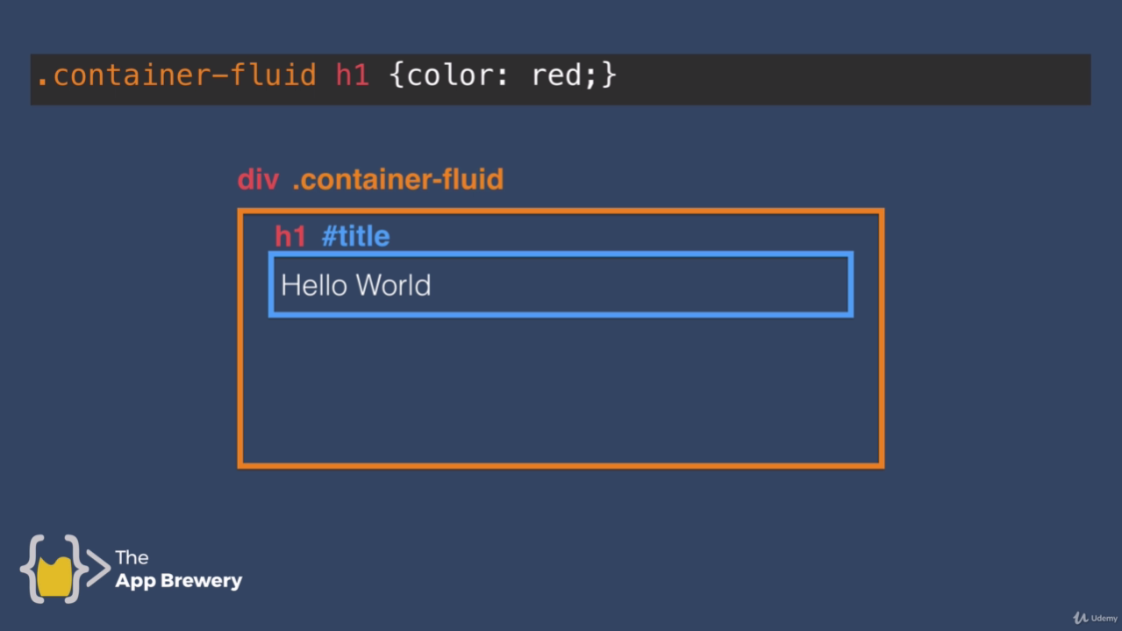

Hierarchy is from right to left. Title color will be red that is inside the div.

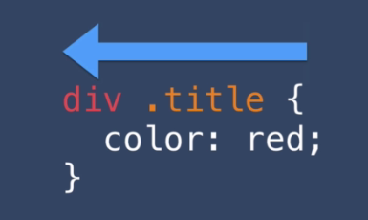

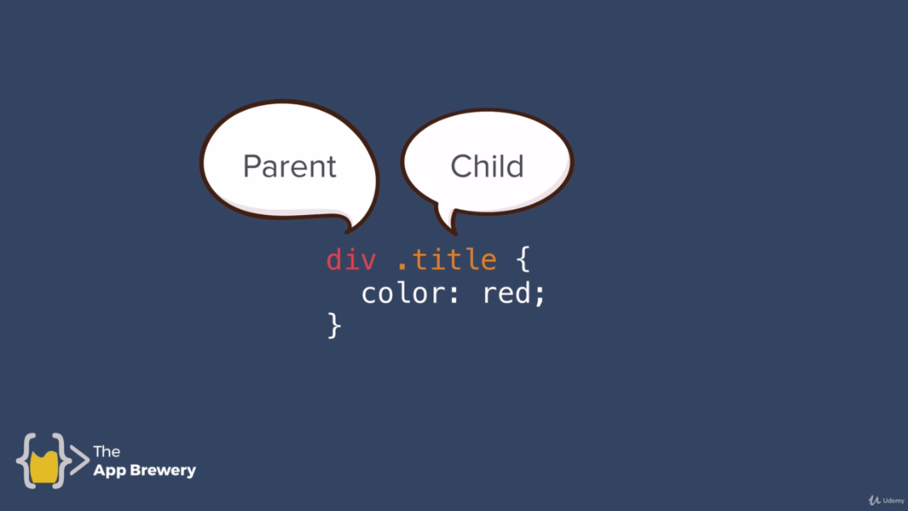

**Combined Selectors:**

Syntax: <Selector1>.<Selector2> /* There’s no space between selector1 and selector2 */

Selector1.selector2{

}

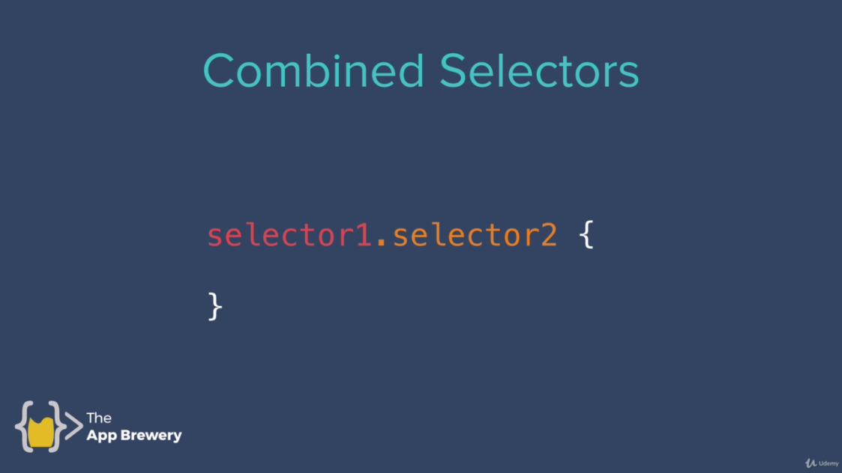

In above case there is no space between two selectors. An HTML element is combined with class.

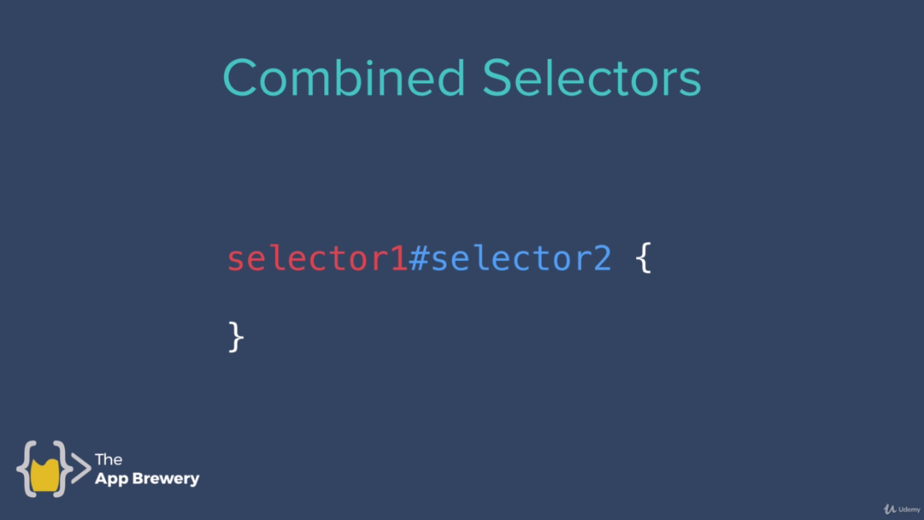

HTML element is combined with ID. H1 that have an id of title will be colored red.

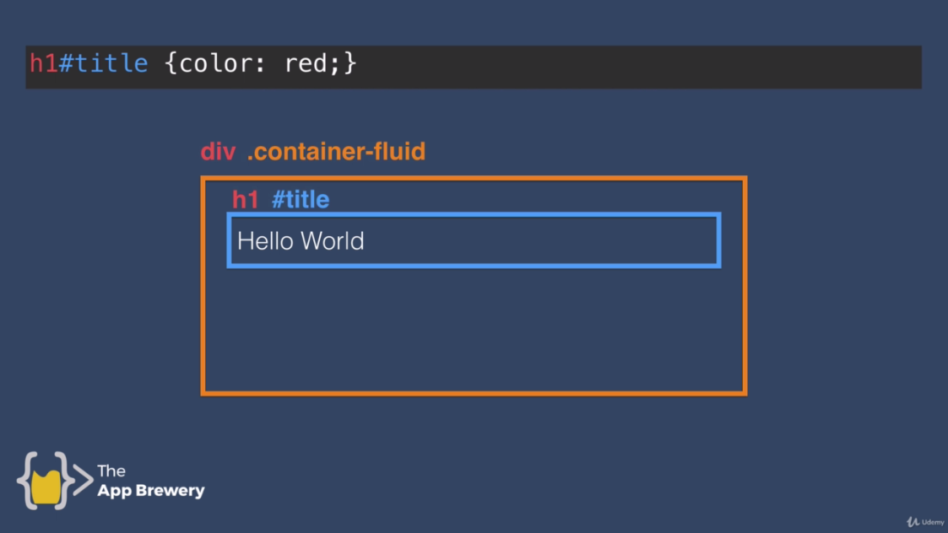

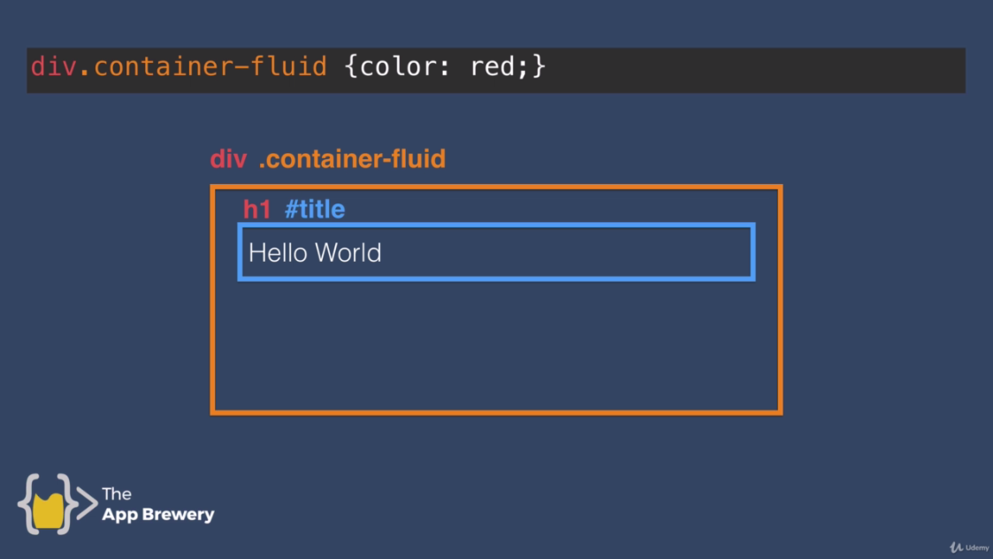

This will not work.

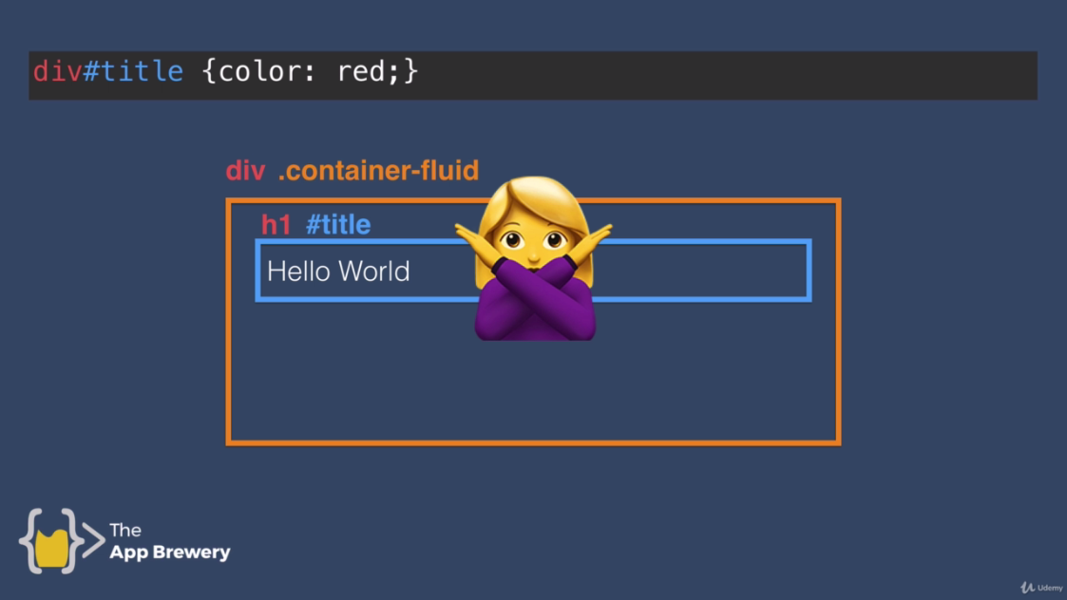



**Codes:**

**Code1:**

**CSS:**

/* .container .title{

color:red;

}

h1.container.title{

color:red;

}

*/

.container.title{

color:red;

} //Apply one by one

**HTML:**

<div class="container">

<h1 class="title">Hello World!</h1>

</div>

<div class="container-fluid">

<h1 class="title">Good Bye World!</h1>

</div>

**Code2:**

**CSS:**

h1#heading{

color:red;

}

**HTML:**

<div class="container">

<h1 id="heading" class="title">Hello World!</h1>

</div>

<div class="container-fluid">

<h1 class="title">Good Bye World!</h1>

</div>

**Code3:**

**CSS:**

h1.title{

color:red;

}

**HTML:**

<div class="container">

<h1 id="heading" class="title">Hello World!</h1>

</div>

<div class="container-fluid">

<h1 class="title">Good Bye World!</h1>

</div>

**Code3:**

**CSS:**

**HTML:**